CHAPTER 4

DEPARTMENT ORGANIZATION AND COMMAND STRUCTURE

04.010 The Divisions

The Stevens County Sheriff's Department consists of three major divisions: operations, investigations and administrative.

1. Operations Division:

The Operations Division carries the major burden of the day to day workload. This division is further broken down as follows:

a. Patrol Unit.
The patrol unit is under the supervision of the Undersheriff and consists of deputies assigned to patrol, respond to complaints or citizens requests for assistance, and conducting preliminary investigations in their assigned area.

b. Corrections Unit.
The jail is under the supervision of the Undersheriff, with a Chief Corrections Officer in charge of the day to day management. This unit has responsibility for detention, feeding, medical attention and transportation to court for all persons lodged in the Stevens County Jail. A separate policy and procedures manual exists for the running and management of the jail.

2. Investigation Division:

The Investigation Division handles the follow-up of complaints and long term investigations under the supervision of the Inspector. This division is further broken down as follows:

a. Detective Unit.
This unit handles the routine follow-up investigations. Officers of this unit are responsible for the processing of evidence gathered from the crime scene, gathering further facts, and preparing evidence and testimony for court proceedings regarding the crime.

b. Identification Bureau.
This unit is responsible for the processing of physical evidence that has been logged for a search of latent fingerprints.

c. Narcotics Laboratory.
This lab is maintained by an officer of the Investigation Division. Its purpose is to process substances that are suspected to be of a narcotic or drug nature.

3. Administrative Division:

The Administrative Division is under the direct supervision of the Undersheriff. This division is further broken down as follows:

a. Civil and Evidence Unit.
This unit handles all civil process, the service of such court documents and the associated paper work needed upon completion. All property attachments, real and personal, the enforcement of court orders. Concealed weapon permits, special wood products permits, and other special permits are issued from this unit. All monies received are processed and distributed to their respective receivers and accounted for.

This unit is also responsible for maintaining evidence and property. All physical evidence is processed through this unit, stored in secure locations and disposed of according to law.

b. Records Unit.
This unit is responsible for maintaining a complete system of records on complaints, reports, and department equipment.

c. Administration.
Planning and research, budget, emergency services, and other support services as needed are handled and supervised by the Undersheriff.

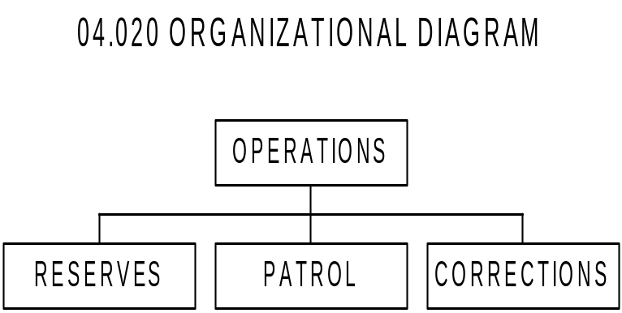

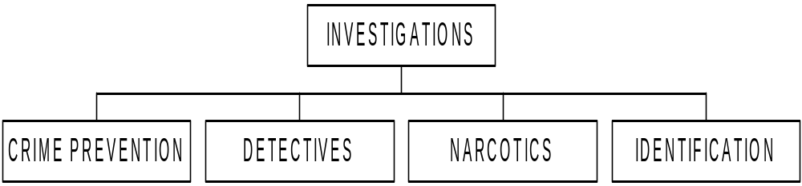

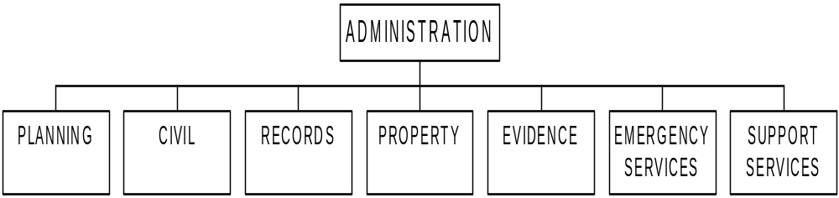

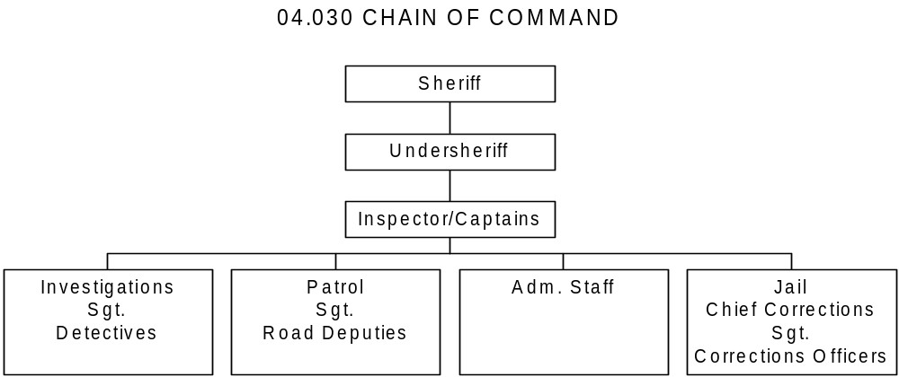

04.040 Civil Service Status

SHERIFF Elected, public official

UNDERSHERIFF Appointed by the Sheriff
INSPECTOR/CAPTAIN Appointed by the Sheriff
CHIEF CRIMINAL DEPUTY Appointed by the Sheriff
ADMINISTRATIVE ASST. Appointed by the Sheriff

PATROL SERGEANT Selected by the Sheriff from Civil
Service List
DETECTIVE Selected by the Sheriff from Civil
Service List
PATROL DEPUTY Selected by the Sheriff from Civil
Service List
CIVIL DEPUTY Selected by the Sheriff from Civil
Service List
CHIEF OF CORRECTIONS Selected by the Sheriff from Civil
Service List
CORRECTIONS OFFICER Selected by the Sheriff from Civil
Service List

